Chestnut Elementary School Library
Collection Development Plan and Action Plan
October 27, 2020
Written by Janette Rios

Gary Bressler, Principal
Megan Faust, Assistant Principal

Janette Rios, Media Specialist

Table of Contents
Purpose Statement pp 3-4
Background
Responsibility and Criteria
Size of the Collection
Mission/Vision, and Goal
Target Audience
Budget/Funding

Evaluation Criteria pg 4
Collection Analysis pp 5-7
Title Wise
Rainbow Books

Selection Aids pg 8
Intellectual Freedom pg 8
Weeding Plan pg 10
Gifts
Replacements
Special Collections

Appendices
Appendix A pg 11
ALA Library Bill of Rights

Appendix B pp 12-13
Reconsideration Form

Appendix C pg 14-16
Media Advisory Committee Reconsideration Checklist

Action Plan pg 17

Purpose Statement: The purpose of this comprehensive collection development plan is to provide guidelines for the targeted selection of media program materials and utilization of budgeted funds. The collection development plan reflects goals which support the curriculum, patron educational needs and Reading promotion. It will be reviewed and revised every year with approval from Administration and the Media Advisory Committee. This is done to build a superior collection that is balanced, diverse and meets curriculum needs.
Background Statement: Chestnut Elementary School for Science and Engineering serves a diverse population of approximately 652 students. The school is a Title I school as well as an AVID (Advancement Via Individual Determination) and STEM (Science, Technology, Engineering and Mathematics) school. The student population is made up of 50.89% male students and 49.11% female students which represent the following cultures and ethnicities in the indicated amounts: American Indian/Alaskan Native 0%; Asian/Pacific Islander 2.38%; Black or African American 21.40%; Multiracial 67.01%; White 9.21%. Current enrollment per grade level is as follows: PreK – 23; K – 102; First Grade – 88; Second Grade – 83; Third Grade – 115; Fourth Grade – 114; Fifth Grade – 110; ESE Self-contained ASD - 34. Due to the COVID-19 pandemic which is currently affecting the United States and the state of Florida, learners mentioned in the demographics data include those who are participating in learning via the virtual platform, Microsoft Office TEAMS. The participation in the Universal Breakfast program and Community Eligibility Program (CEP) respectively provide breakfast and lunch at no cost to all students. These programs are made possible due to high need and participation in the breakfast and lunch program.
Responsibility and Criteria for Collection Development: Chapter four of the Osceola County School Board Policy Manual, (rule 4.21 and 4.22 Educational Media Materials Selection), sets objectives, criteria and procedures related to collection development and materials selection at the school and district level. In accordance with Florida state statutes and regulations, procedures are implemented for challenged materials as well. (Please see the sections titled Evaluation Criteria and Intellectual Freedom). Selection objectives for media collections clearly state:
“The primary objective of the school’s media center is to implement, enrich and support the educational program of the school…. Materials placed in Media collections shall meet the criteria set forth in the Osceola County Media Handbook” (Osceola School Board, 2016).

Collection development for Chestnut Elementary school is made by the on-site Media Specialist with guidance from the Osceola County Media Handbook, selection aids and in collaboration with teachers and staff. An ongoing consideration file is also collaboratively reviewed. Additionally, the Media Advisory Committee may provide valuable feedback in materials selection. However, the Osceola School Board is the final authority related to materials acquisition.
Size of the Collection: The standard set forth by the Southern Association of Colleges and Schools (SACS) recommends that a balanced media program have an adequate number of books per student.
Mission/Vision and Goals: Mission: The mission of the Chestnut Elementary media program is to provide learners with access to a sufficient amount of print and non-print resources that are necessary in enhancing and expanding their instructional learning gains. Vision: The vision of the Chestnut Elementary library media program is to foster a love of reading while empowering all learners to become self-directed learners, thinkers and creators as they utilize digital, virtual and print resources. Goal: The goal of the Chestnut Elementary media program is to maintain a collection that is current, balanced, culturally diverse, and in keeping with the educational curriculum needs of all patrons.
Target Audience (Patrons): Elementary school learners, teachers and staff.
Budgeting and Funding: The utilization of funds and the projected balance for the Chestnut Elementary media program is determined using the collection analysis and pends on the availability of funds. Funding has been severely impacted due to the COVID-19 pandemic. Funding for the library media program is usually obtained from allocated money from the Osceola School District which is determined at a per pupil rate based on FTE attendance. The per-pupil funding rate for 2020-2021 is: $3.55 per student as per the October FTE for a total allocation of $2296.85. Internal library accounts that fund the media program are: Media Center (project # 5382757), Media lost/damaged books and fines (project # 5383257) and Media Book Fair (project # 5383557). The School Advisory Council (SAC) and Parent Teacher Organization (PTO) may provide additional funds upon request and after approval. Typically, the funds allocated to the Media Book fair funds are raised through the Scholastic book fairs which take place twice a year. These funds serve for collection development, supplies, as well as reading incentives and professional development. The COVID-19 pandemic currently affecting the United States and the state of Florida is severely impacting fundraising efforts.
Evaluation Criteria: Evaluation and selection of materials is a continuous collaborative process. The evaluation criteria for print as well as non-print materials for media programs across the Osceola county school district is set forth in the School Board policy manual. Additionally, the on-site Media Specialist uses professional judgement, selection aids and requests from an ongoing order consideration file which teachers and or students may fill out. The criteria for materials selection for print and non-print resources includes: Educational significance, collection analysis determinations (such as age of the collection), literary merit, reliability, relevancy, and aesthetic quality.

Collection Analyses: A collection analysis is conducted twice a year during the school year to ensure best practices when weeding and determining areas of improvement. These analyses are part of the selection aids that the Media Specialist utilizes during collection development. The following collection analyses have been obtained after Marc records uploads to the following vendors: Follett, Rainbow Books and Bound to Stay Bound. Although the analyses were obtained from vendors, this in no way influences the Media Specialist purchasing of materials in favor of these vendors.
Follett: Follett Title Wise Collection Analysis conducted on October 23, 2020 revealed that the average age of the collection was 2005 with 13.4 items per student. 45% of the collection is general fiction with an average age of 2004 while 55% of the collection is non-fiction with an average age of 2007. Only 11% of the collection is 2015 or newer. A detailed look at each Dewey section revealed the following age-sensitive areas that must be weeded and updated: 12.4% of the aged general fiction titles in the collection has an average age of 1997 while the 14.6 % of the aged titles in the nonfiction collection has an average age of 2002. The majority of the aged titles in the nonfiction section are located within the following Dewey classification areas: Astronomy/Allied Sciences, Life Sciences/Biology, Medical Sciences, and Geography/Maps, Atlases. (Please see Table 1). Further analysis of the collection showed that 27% of the collection supports Diversity and 29% of the collection supports Social Emotional Learning. The Title Wise analysis indicates that the collection needs extensive weeding in the fiction section and urgent updating in the aged Dewey classifications as listed (I.e., 500-529; 570-579; 610-619; 910-919). Additional titles to support Diversity and Social Emotional Learning (SEL) are also needed.

Table 1 (Follett Title Wise Analysis)
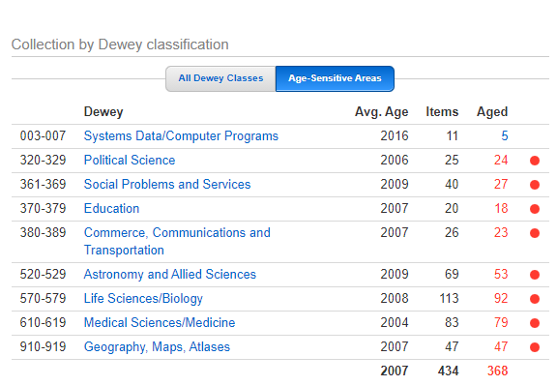
Table 2 (Follett Title Wise Analysis) Ebooks are included in a separate analysis, not shown
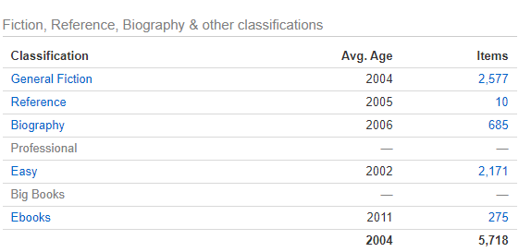

Rainbow Books: A Rainbow Books Collection Analysis conducted October 27, 2020 corroborates the findings of the Title Wise Analysis. The Title Wise Analysis considers the CREW formula whereas the Rainbow analysis with custom age report which appears to be more stringent. The analysis revealed the following age sensitivity and deficiencies which need to be corrected in order to meet our ongoing mission and goal:
Table 3
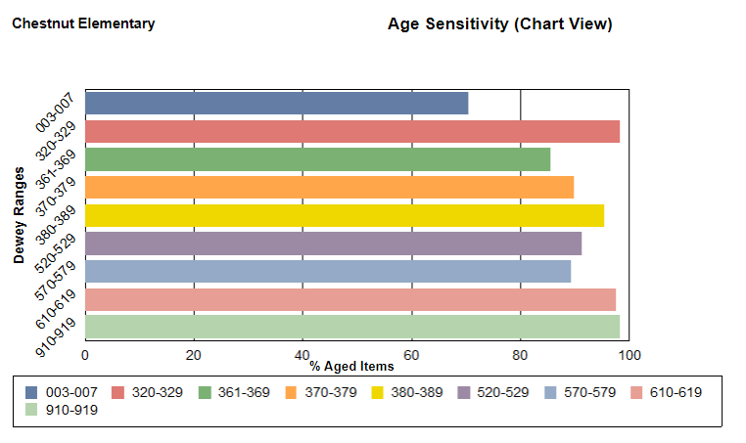

Table 4
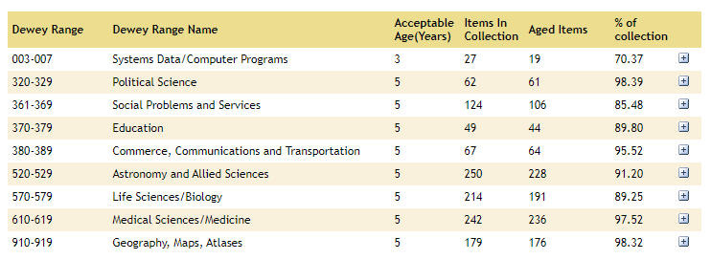

Selection Aids: Selection aids include but are not limited to the following resources:
- Booklists
- Cooperative Children’s Book Center (CCBC)
- Kirkusreview.com
- Library Journal
- School Library Journal
- American Library Association (ALA) Awards list
- SSYRA and SSYRA Jr. Award list
- Horn Book
- Teachers and students
- Jobbers such as Follett, Rainbow Books, Bound to Stay Bound Books, Children’s Plus, Mackin

Intellectual Freedom: “Intellectual freedom is the right of every individual to both seek and receive information from all points of view without restriction” (ALA.org, 2016). It is the position of this media program that intellectual freedom is protected by the First Amendment of the Constitution which cites that the people have freedom of the press and freedom of speech. In keeping with these democratic ideals, the Chestnut Elementary Media program supports the points of view set forth by the American Library Association in the Library Bill of Rights, the Freedom to Read Statement and the Academic Freedom policy statement. Despite careful selection of instructional materials by qualified personnel using approved procedures and established criteria, occasional requests for reconsideration of material may arise. Any complaint regarding challenged materials must follow the protocol established by the Osceola County School Board Policy Manual in accordance with Florida state statutes.
Challenging Materials: Osceola County has established specific procedures for reconsideration of instructional materials circulated within the media program. These can be found in the Osceola County School Board Policy Manual. (See excerpt below; Appropriate forms can be found in Appendix B. See Appendix A for the Library Bill of Rights which speaks to this topic).
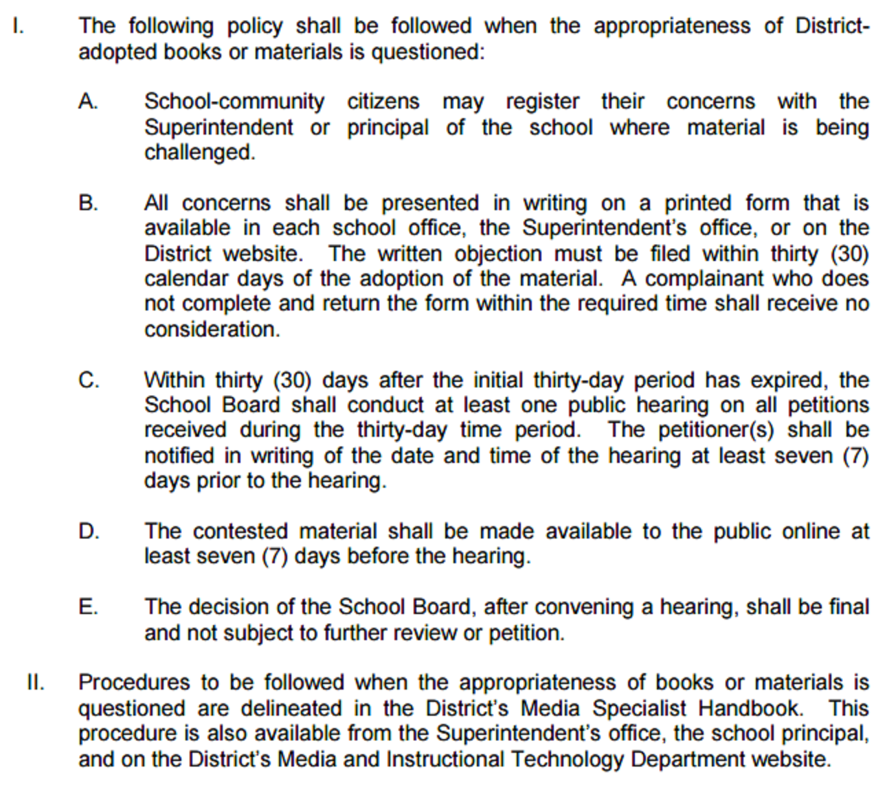

Weeding: Weeding is part of a systematic analysis of the collection and must be an ongoing process. Part of a Media Specialist’s job is to assume responsibility for the quality and condition of the collection. A superior library collection development plan includes principles of weeding which facilitate access to quality resources. The weeding criteria that has been adopted by Chestnut Elementary media program is called the Continuous Review, Evaluation and Weeding (CREW) method which refers to the MUSTIE guide, (Misleading, Ugly, Superseded, Triviality, Irrelevant, Elsewhere) . It is important to note that professional judgement must also be used when weeding the collection. A detailed explanation of the method can be found in the hyperlink below.
https://www.tsl.texas.gov/sites/default/files/public/tslac/ld/ld/pubs/crew/crewmethod12.pdf

Gifts: The Chestnut Elementary library is pleased to accept gifts/and or memorial gifts from patrons. Gifts are graciously accepted as long as no restriction on use and disposition is placed upon it. Acceptance of gifts (of books and other library material) will be at the Media Specialist’s discretion on the basis of literary merit and suitability as stated in the collection development policy. The library has the right to discard any gifts at any time for any reasonable reason. Gifts of books are not currently being accepted due to the ongoing COVID-19 pandemic.

Replacements: Replacement copies of titles within the collection will be replaced as necessary. Patrons who lose a book or damage a book may replace the book in lieu of payment as long as the copyright date is the same or newer and the book is in new condition. Patrons who lose or damage books will receive a notice with the original price of the book. Upon payment, the patron will receive a Destiny generated receipt and/or a school receipt.

Special Collections: Special Collections are located within the teacher resource rooms in the Media Center. Materials in these resource rooms should benefit multiple teachers and/or grade levels. The material is chosen according to publication date, relevancy and curriculum standards. Obsolete items that are broken, out of date or no longer meet curriculum standards and student interests or do not represent the student population will be discarded as deemed necessary.
Appendix A
LIBRARY BILL OF RIGHTS
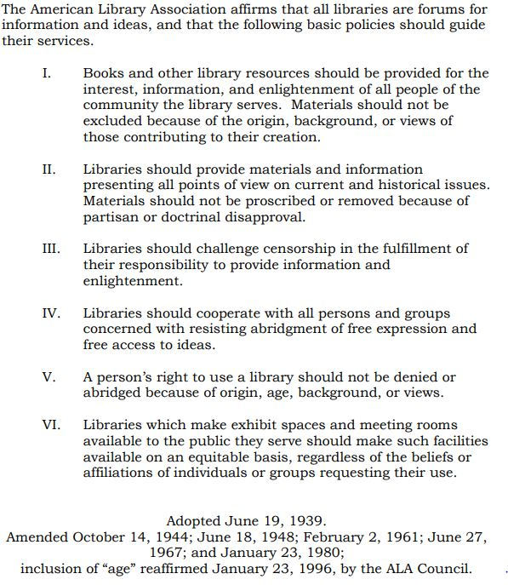

Appendix B
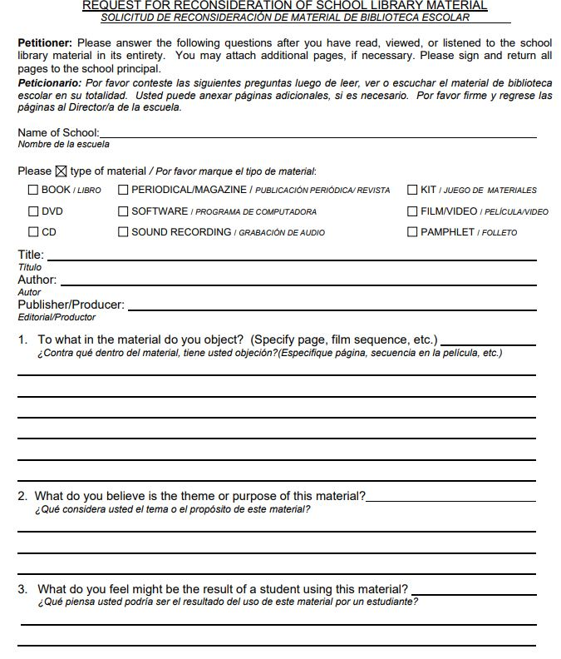

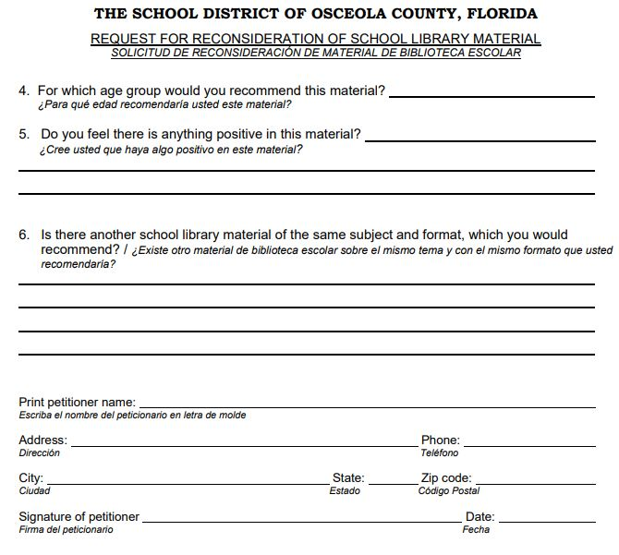

Appendix C
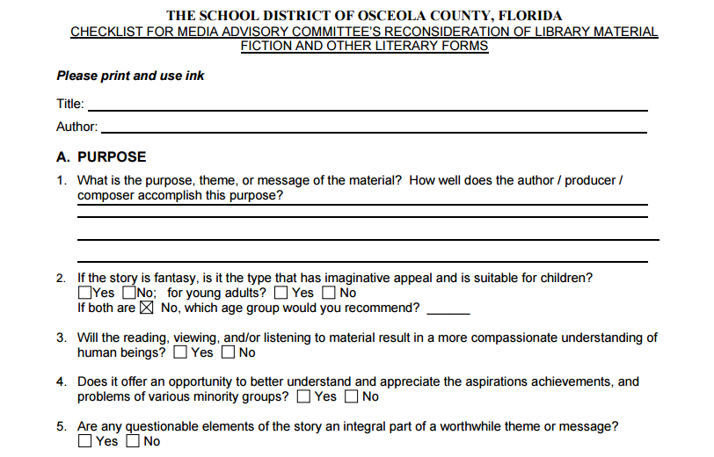
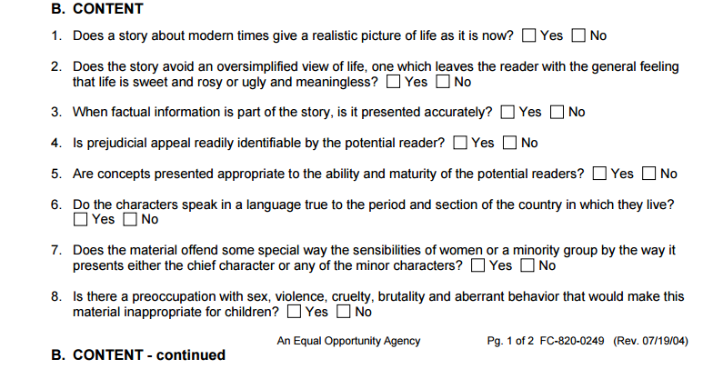

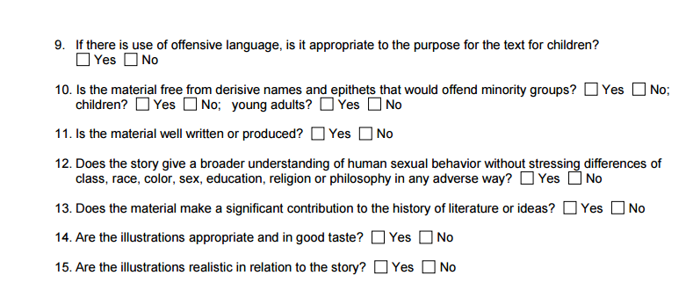
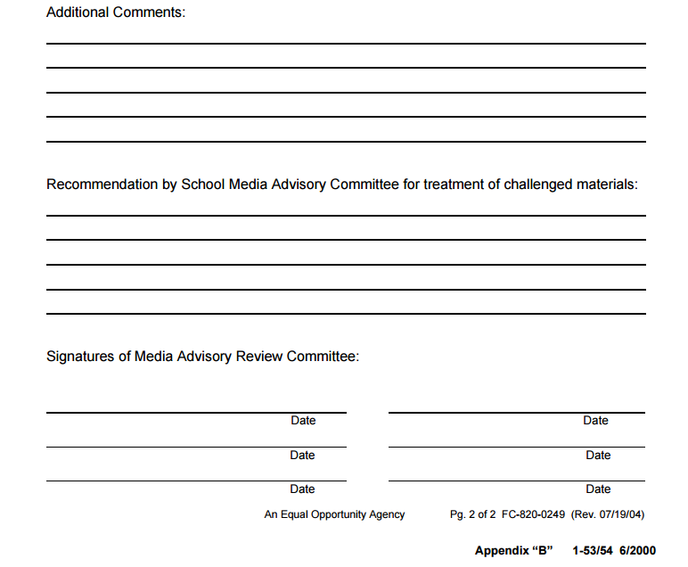

ACTION PLAN STATEMENT

Based on an analysis of the collection and the criteria set forth by the Osceola School District, CREW Method and professional judgement, the following areas are in critical need of weeding and improvement:
- Non-fiction Section
- Fiction Section
- A physical inspection of the collection also revealed the following: The majority of the fiction chapter books are paperback books which are easily torn and are falling apart. They must be replaced with newer, hard cover versions.
- Extensive weeding in the past has reduced the number of books in the collection significantly. To correct this problem, many new books which represent the interests of our student population and meet curriculum must be purchased.

An end of year analysis will be conducted to determine improvements after weeding and purchasing of resources has taken place. The collection development plan will be reviewed in one year with Administrative approval and Media Advisory Committee input. However, the current statistics show that an efficient five-year plan for the Chestnut Elementary Media Center should include updates and replenishments in the following Dewey sections: 300’s; 500’s; 600’s; 900’s; Fiction, due to low numbers and aged titles. In order to provide a more efficient and seamless experience this library program will also begin genrefying the collection within the next three years. This goal has been modified to allow for interruptions and budgetary constraints due to the ongoing COVID-19 pandemic.

